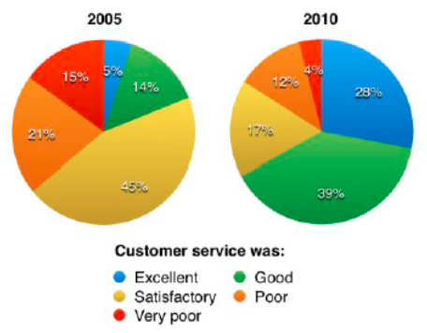

The pie charts compare visitors’ responses to a survey about customer service at the Parkway Hotel in 2005 and in 2010.

It is clear that overall customer satisfaction increased considerably from 2005 to 2010. While most hotel guests rated customer service as satisfactory or poor in 2005, a clear majority described the hotel’s service as good or excellent in 2010.

Looking at the positive responses first, in 2005 only 5% of the hotel’s visitors rated its customer service as excellent, but this figure rose to 28% in 2010. Furthermore, while only 14% of guests described customer service in the hotel as good in 2005, almost three times as many people gave this rating five years later.

With regard to negative feedback, the proportion of guests who considered the hotel’s customer service to be poor fell from 21% in 2005 to only 12% in 2010. Similarly, the proportion of people who thought customer service was very poor dropped from 15% to only 4% over the 5-year period. Finally, a fall in the number of ‘satisfactory’ ratings in 2010 reflects the fact that more people gave positive responses to the survey in that year.

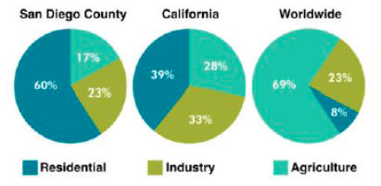

The pie charts give information about the water used for residential, industrial and agricultural purposes in San Diego County, California, and the world as a whole.

It is noticeable that more water is consumed by homes than by industry or agriculture in the two American regions. By contrast, agriculture accounts for the vast majority of the water used worldwide.

In San Diego County and California State, residential water consumption accounts for 60% and 39% of total water usage. By contrast, a mere 8% of the water used globally goes home. The opposite trend can be seen when we look at water consumption for agriculture. This accounts for a massive 69% of global water use, but only 17% and 28% of water usage in San Diego and California respectively.

Such dramatic differences are not seen when we compare the figures for industrial water use. The same proportion of water (23%) is used by industry in San Diego and worldwide, while the figure for California is 10% higher, at 33%.